Madison Park Sign Standards

The Madison Park HOA Board of Directors has established guidelines on all “for sale” or “for rent” signs. The goal of the standards is to achieve a unique matched look in Madison Park where all signs (Entrance, Developer, Realtor, Model, For Sale, For Rent, For Sale by Owner, etc.) share a common appearance. All Solicitation signs are prohibited.

- Signs must have the Madison Park logo and colors as shown below.
- All additional print must be “white”
- All signs must be placed in the front yard “devil strip.”
- No “information flyers” will be allowed.
- No Balloons allowed.
- No Directional Arrows or Signs are allowed at the Entrance of the Community.

HOW TO ORDER SIGNS:

FASTSIGNS – contact: Clint Coleman (919-872-9522)
2621 Spring Forest Rd.
Raleigh, NC 27616

(1) 18 x 24 Aluminum identification sign
(1) 18 x 24 Black metal frame w/rider space
(1) 6 x 24 Rider (that can receive text/logo) in green/white
(1) 6 x 24 SOLD rider in green/white

**Please allow 2-3 business days to make sign

* You may customize your sign and rider with realty company logo, names and contact information.

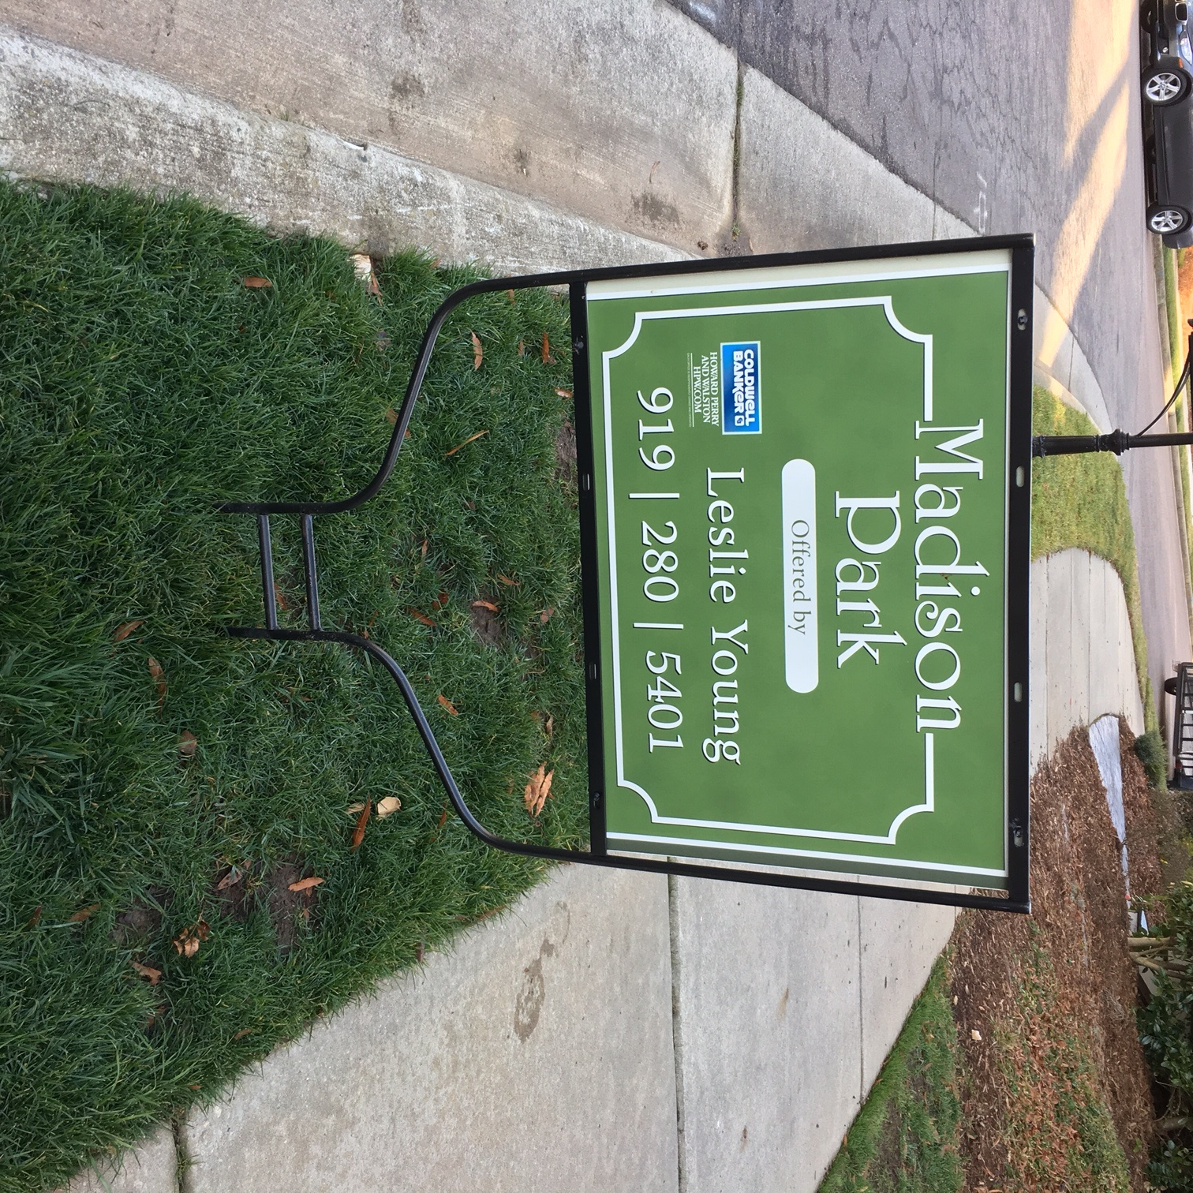

~ SAMPLE ~

